clean arch .NET Core 7 REST API + JWT Role+Claim based Authn + AspNetCore Identity + EFCore + SQL Server project STEP by STEP:
Creates a SQL Server empty Db; in VS2022 creates clean arch .NET Core 7 REST API project; in appsettings.json setup Db Connection string URL to our SQL Server empty Db; in appsettings.json setup JWT section key/value: Issuer, Audience, SecretsKey, TokenValidationInMinutes, RefreshTokenValidity; in appsettings.json setup EmailConfiguration section key/value: From, SmtpServer, Port, email acct username, password; in User’s email acct, setup email acct to generate a 2 factor password & copy password value & paste it as EmailConfiguration section password key value; in appsettings.json setup AzureKeyVault section keys/values; in appsettings.json setup Serilog structure logging write log to console, to file, & to Db; in VS2022 creates a Db Project; creates/run script tables, script stored procs, script inserting data into tables; in VS2022 publishes Db Project to our SQL Server empty Db; in API Domain project’s Entities folder creates entity models; in API Infrastructure project’s Data folder creates DataContext class; run add-migration creates Db scripts; run update Db so Microsoft.AspNetCore.Identity creates AspNetRoleClaims, Roles, UserClaims, Logins, UserRole, Users, UserToken tables in our Db; in API Application project’s DTOs folder creates DTO models; In REST API project’s Controller folder creates AuthenticationController.cs; add post registration action method; User submits password, confirmpassword, username, email, role(s) to backend; backend checks if User exists, if yes, notify User already existed; if not, Microsoft.AspNetCore.Identity creates new User in AspNetUsers table; uses User’s password & creates passwordHash then saves User’s username, passwordHash to User in Db AspNetUsers table; Backend System.IdentityModel.Tokens.Jwt generates registrationToken; composes & sends email(SMTP MailKit)+registrationToken+confirmationLink to User’s email acct; User clicks email’s registrationToken confirmationLink; automate callback backend post RegistrationEmailConfirmation action method; backend validates User exist; if yes, Microsoft.AspNetCore.Identity verifies submitted registrationToken; if registrationToken validation succeed, Microsoft.AspNetCore.Identity userManager enables User’s ‘EmailConfirm’ field in AspNetUsers table; Now User created & saved in Db AspNetUsers table; in VS2022 AuthenticationController.cs creates Login post action method; when registered User Login & submits username, password; backend checks if User existed, if no, return unauthorized login; if yes, backend checks if User’s ‘TwoFactorEnabled’ field enabled in AspNetUsers table; if enabled then System.IdentityModel.Tokens.Jwt generates JWT acessToken, refreshToken & return them to User; if not enabled Microsoft.AspNetCore.Identity logout User’s session; then Microsoft.AspNetCore.Identity login to system; System.IdentityModel.Tokens.Jwt generates 2FToken; backend composes email with 2FToken & User’s email & sends to User’s email acct; User Login2FToken post action method with generated 2FToken & username; Microsoft.AspNetCore.Identity authenticates 2FToken & username, if User existed & 2FToken authentication succeed, then signInManager.TwoFactorSignInAsync; if TwoFactorSignInAsync succeed, Microsoft.AspNetCore.Identity enables User’s ‘TwoFactorEnabled’ field in AspNetUsers table; then Microsoft.AspNetCore.Identity setup & creates System.Security.Claims key/value: Issuer, Audience, SecretsKey & checks submitted Role(s) matching AspNetUserRoles table pre-defined Roles, if yes, assigns Role(s) to User in System.Security.Claims; if creates System.Security.Claims succeed, then System.IdentityModel.Tokens.Jwt generates JWT acessToken, refreshToken & return them to User; Now acessToken, refreshToken created & returned to User; When User appends accessToken in HTTPS header & submits HTTPS request resources; Microsoft.AspNetCore.Identity authn & authz accessToken & Role; if succeed & if User’s assigned Role has permissions access resources, backend API returns HTTPS response with requested resources to User; Now user can login & request resources by User’s Role permission; When User requests new refreshToken, User submits current jwtAccessToken+username to backend, backend checks if username existed, if yes, backend takes AspNetUser User’s jwtAccessToken & creates a ClaimPrinciple details; backend checks if system’s ClaimPrinciple’s jwtAccessToken matches submitted User’s jwtAccessToken; if yes, Microsoft.AspNetCore.Identity checks if system’s ClaimPrinciple’s refreshToken expired; if true, System.IdentityModel.Tokens.Jwt generates new JWT accessToken+refreshToken & returns them to User, else backend notifies User re-login; Now user has new acessToken, refreshToken; When User requests forgot password; User submits username to backend, backend checks if username existed, if yes, System.IdentityModel.Tokens.Jwt generates PasswordResetToken; backend composes emails & sends PasswordResetToken to User’s email acct, User takes PasswordResetToken & submits PasswordResetToken, new password, confirm password & email to backend; Microsoft.AspNetCore.Identity authenticates PasswordResetToken and User’s identity, if authentication succeed, Microsoft.AspNetCore.Identity saves User’s new/confirm passwords in AspNetUsers table; User new password + confirm passwords reset & saved in Db AspNetUsers table;

JWT with Policy authorization in .NET 8 Web API with Identity Manager
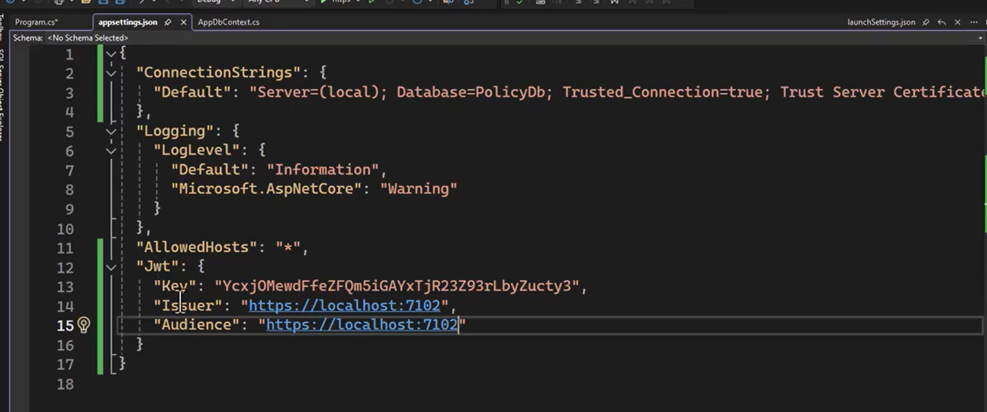

Installed Packages


